**Mastering React-Native**

***“Setting Up Our Environment”***

**Configuring Our Environment**

Due to React Native providing us with the ability to “Write Once, Use Everywhere” using JavaScript, we are able to expedite the process of mobile application development. This means that if we wanted to create an application and launch it to the App Store (IOS) or Google Play Store (Android) we are not required to learn two separate languages for each independent platform. Objective-C (Swift) for IOS development and Java for Android development. Additionally, all user interfaces (UI) are rendered natively when using the React Native framework to develop our apps thus greatly improving our app’s performance in comparison to other frameworks such as Ionic which render component in web views.

**Easy Set-Up (No Xcode or Android Studio Required)**

With this method of setting up our React Native application, we will be using our own mobile devices to view the prospective mobile apps we will be creating. With that being said, you will not be required to download Xcode or Android to view your apps!

**1)**

* Assuming that you do not have node installed on your computer, you will want to head over to <https://nodejs.org/en/download/> and download the most current version that matches your computers’ specifications.

**If you are using windows**

Be sure to download the version of node that matches your operating system (32-bit or 64 bit) or it won’t work!

Once you have installed node, you will now be ready to start the process of creating your first app!

**2)**

* Head over to your terminal(macOS) or command line (windows) and you will be now be able to use “npm” to install the “create-react-native-app” utility.

This can be done by using the following commands:

* **npm install -g create-react-native-app**

to make sure you have full permissions on *macOS* use:

* **sudo npm install -g create-react-native-app**

**3)**

* In order to keep the development process neater, you will want to head over to your desktop and create a new folder called “reactNativePractice” in which you will store all app files created.

**4)**

* In your terminal(macOS) or command line (windows) you will want to change your directory to the newly created one using the following commands:
* **cd desktop**
* **cd reactNativePractice**

**5)**

* Once you’re in your project’s directory, you will now be ready to create a new React Native project called “HelloWorld”. This can be done using the following command:
* **create-react-native-app HelloWorld**

Once that is done, navigate to your newly created project using the command:

* **cd HelloWorld**

and in order to start your development server you will need to use the command:

* **npm start**

**DO NOT Close Your Command Line!**

**Viewing Your Application**

Since we will be using our mobile devices to preview our prospective applications, it will be necessary to install the Expo app on your mobile phones.

* **Expo App Download For IOS:**

<https://itunes.apple.com/app/apple-store/id982107779?ct=www&mt=8>

* **Expo App Download For Android:**

[**https://play.google.com/store/apps/details?id=host.exp.exponent&referrer=www**](https://play.google.com/store/apps/details?id=host.exp.exponent&referrer=www)

* Once you’ve downloaded the respective applications on your device, you will now need to open the app and use it to scan the QR code printed in your terminal(macOS) or command line (windows).

You’ve now created and viewed your first app!

**Integrated Development Enviroment(IDE)**

Microsoft’s visual studio code is amazing when it comes to developing React Native projects. It provides and easy to use interface with many extensions to further aid the process of development thus it will be the primary IDE we will be using.

* In order to use VS code you will be required to download it from <https://code.visualstudio.com/>. Don’t forget to select the correct version for your operating system!

Once you’ve downloaded the Visual Studio Code IDE you will now be ready to open and your react native project within the IDE!

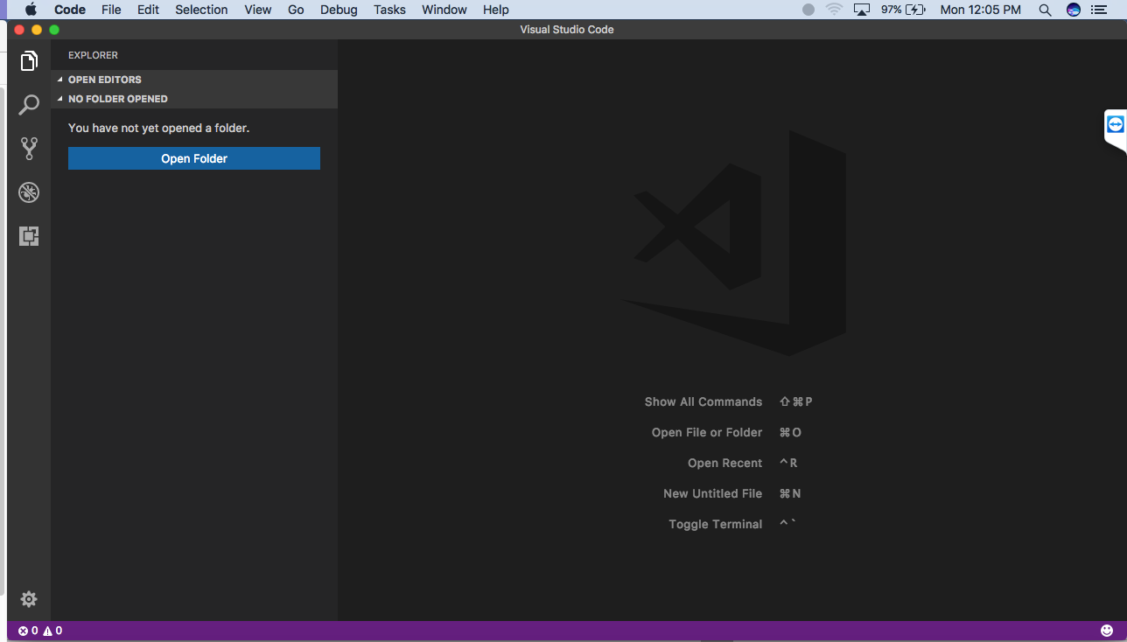**A Visual Of Visual Studio Code (No Pun Intended)**

**Recommended IDE Extensions (You Should Probably Get Them)**

* **JavaScript (ES6) code snippets by -** xabikos.javascriptsnippets
* **React Native Tools by -** vsmobile.vscode-react-native